What does love mean to you?

Some of the students’ answers:

- happiness, being together, feeling lonely, luck, having fun, being sad, gifts, chocolates understanding, disappointment, lack of freedom, insecurity, devotion, loyalty, support, fun, positive attitude...

Conclusion: luckily most of the students have positive emotions towards love, but some of them haven’t been that lucky and have gathered their own, less positive, experiences.

Saint Valentine – his life and death
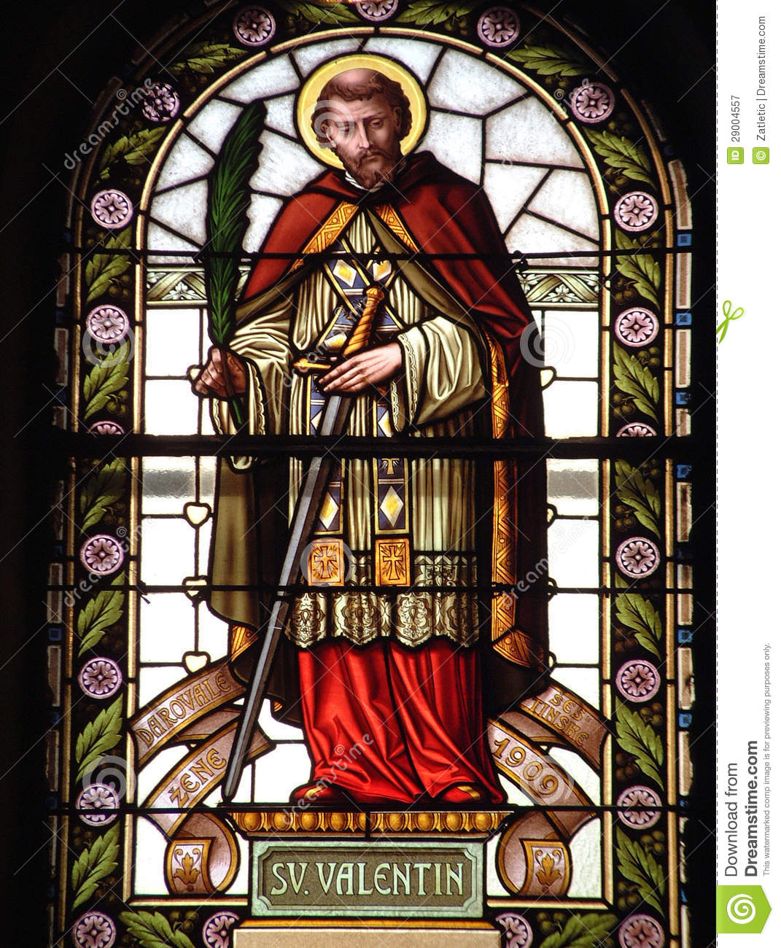

He was a famous saint and there are many stories about him and his life. One of the most widespread believes is that he was a priest from Rome, who lived in the third century AD, the same time when the Roman emperor Claudius II had banned marriage because he believed married men weren’t good soldiers. Because Valentine felt this was unfair, he disobeyed the rules and arranged marriages in secret. When Claudius II found out, what he had been doing, Valentine was thrown in jail, sentenced to death and killed on 14 February.

Atmosphere during the workshop (5 groups, 4 members each, different projects and different tools):

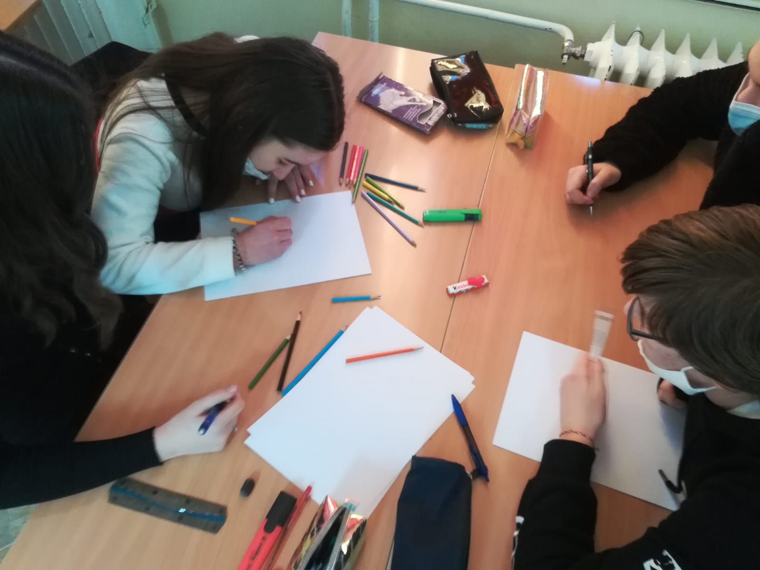
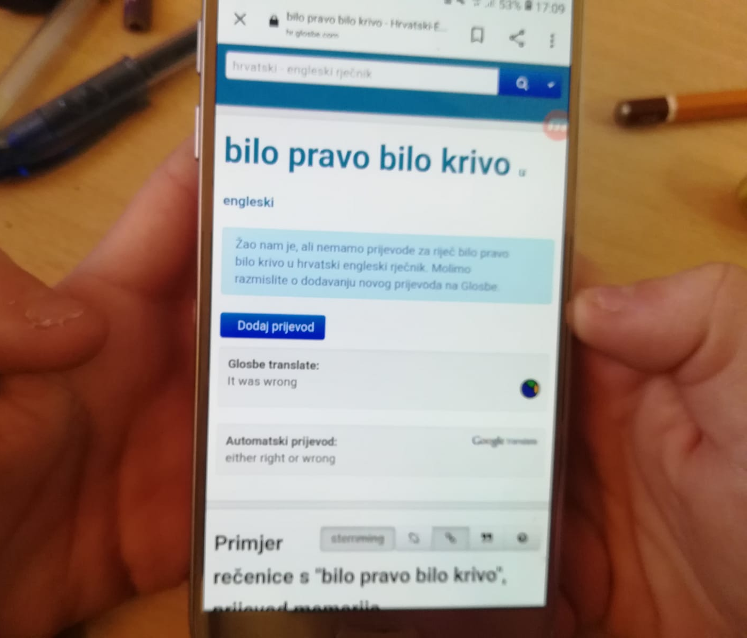

Making a comic without a computer Dictionaries are good, but be careful!

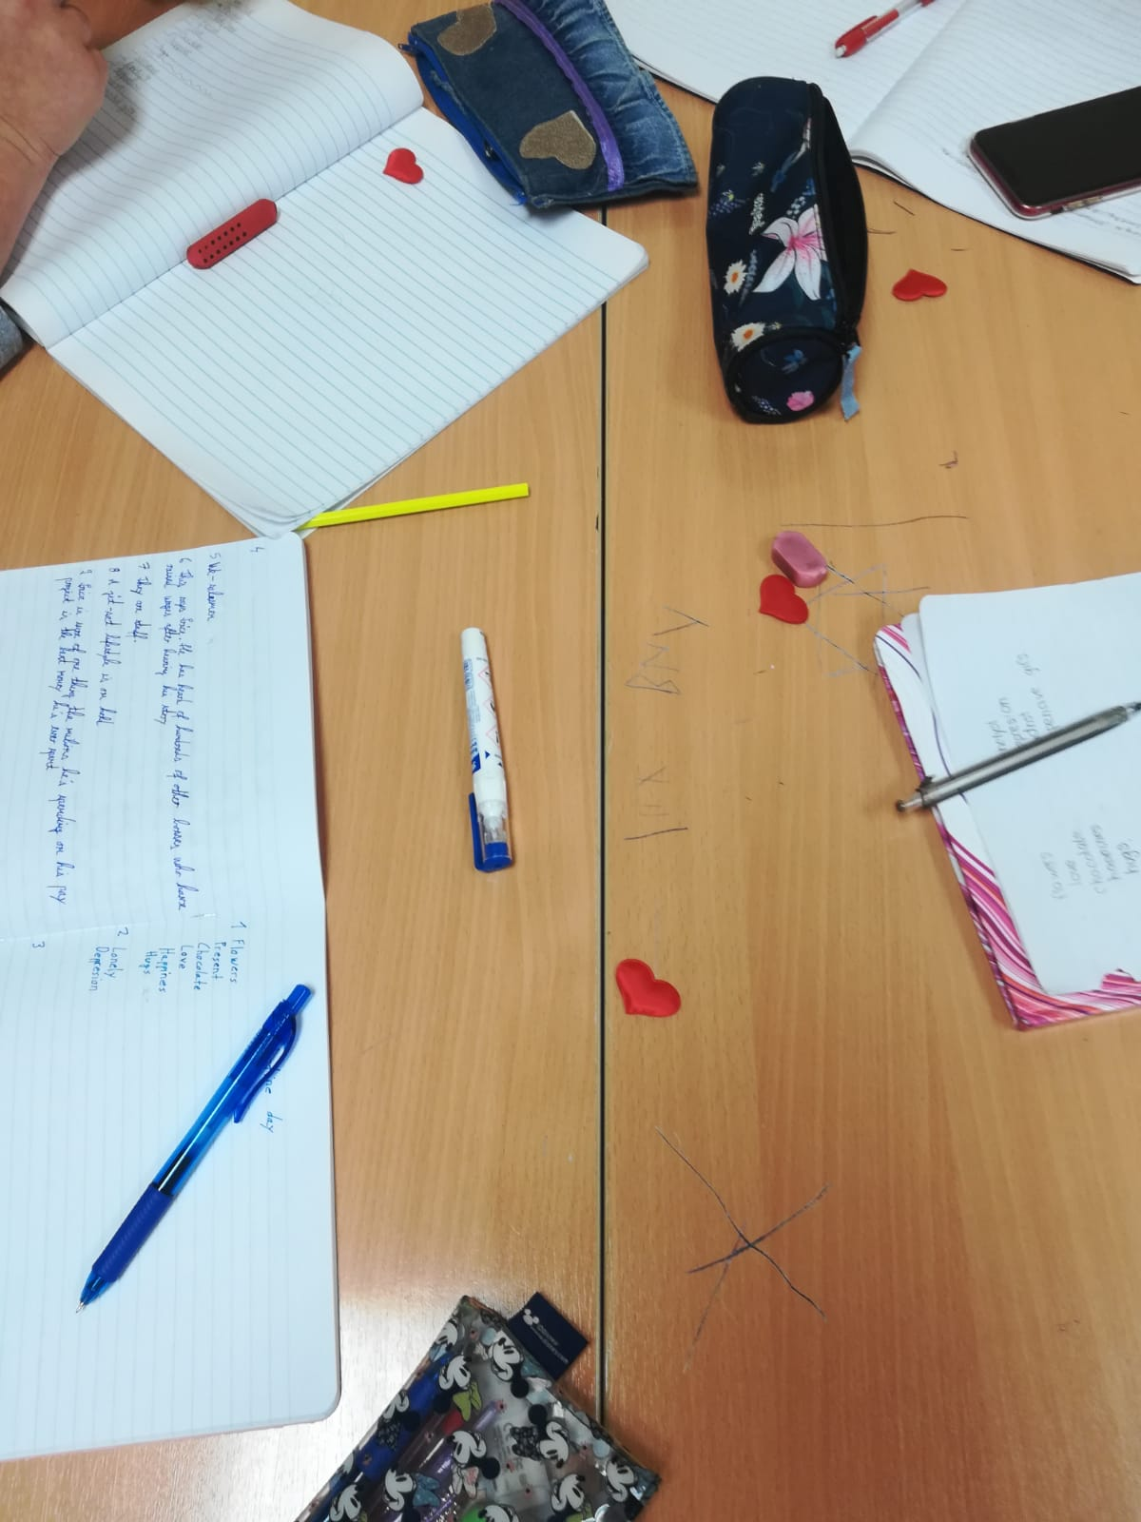
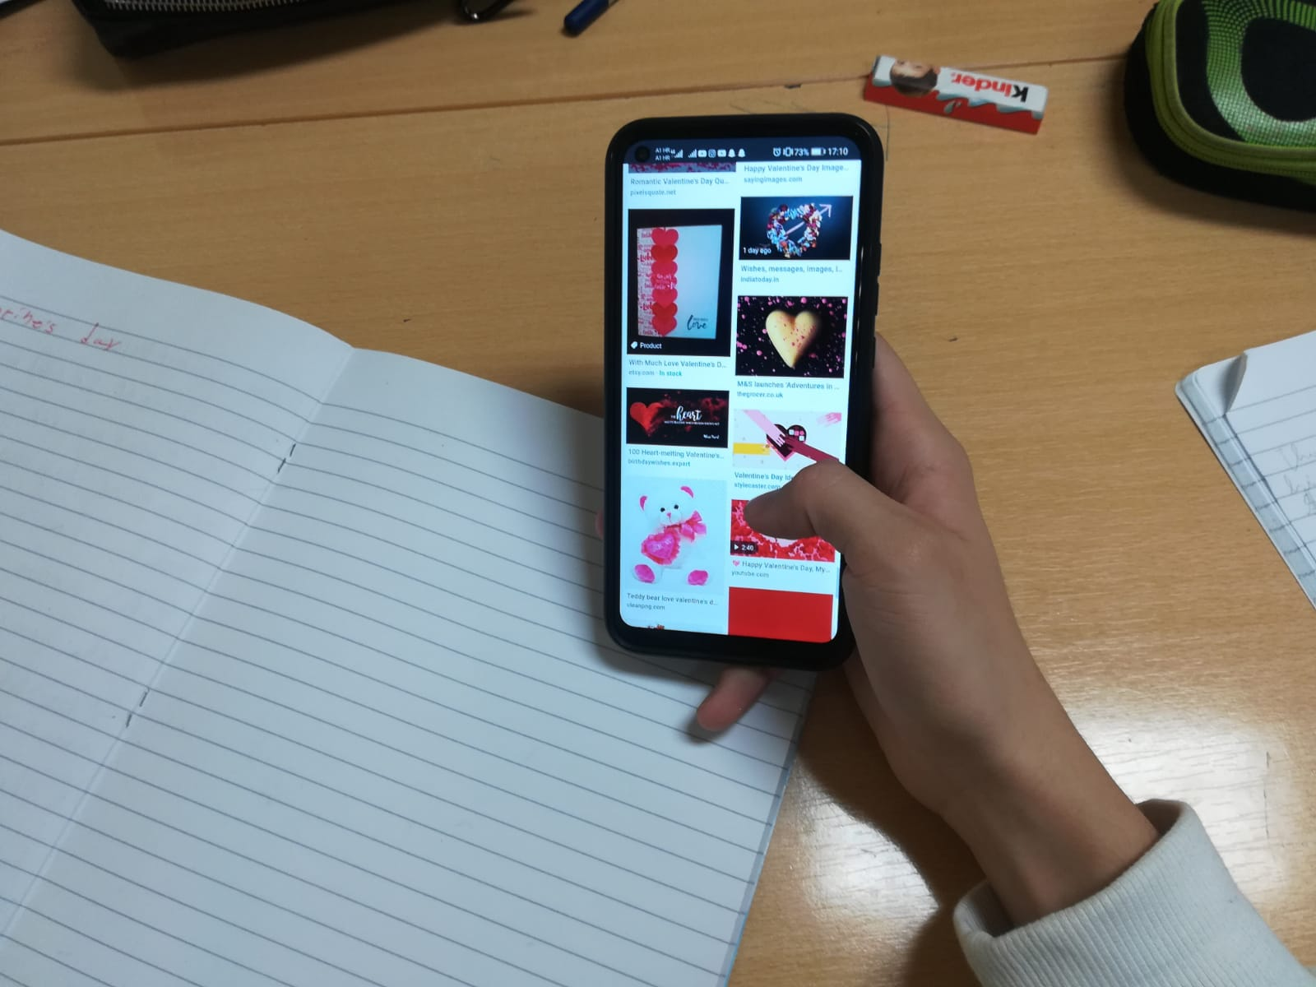

Searching for useful video material Waiting for the inspiration :)

The results of the workshop...

There is always someone who likes you

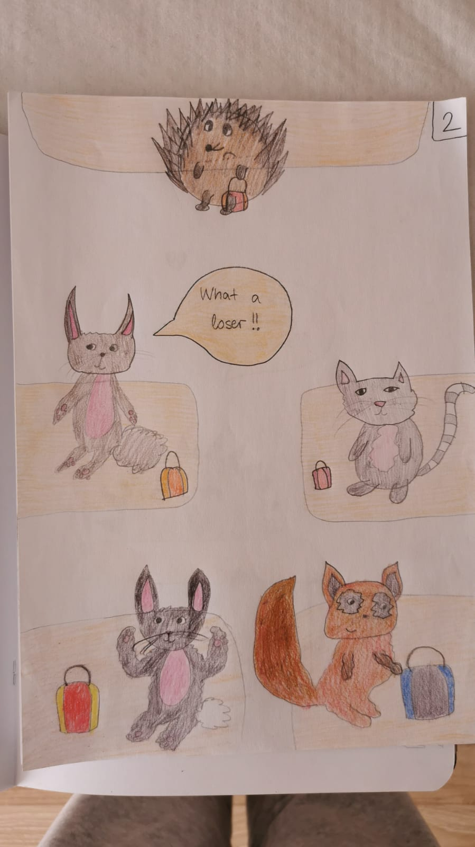
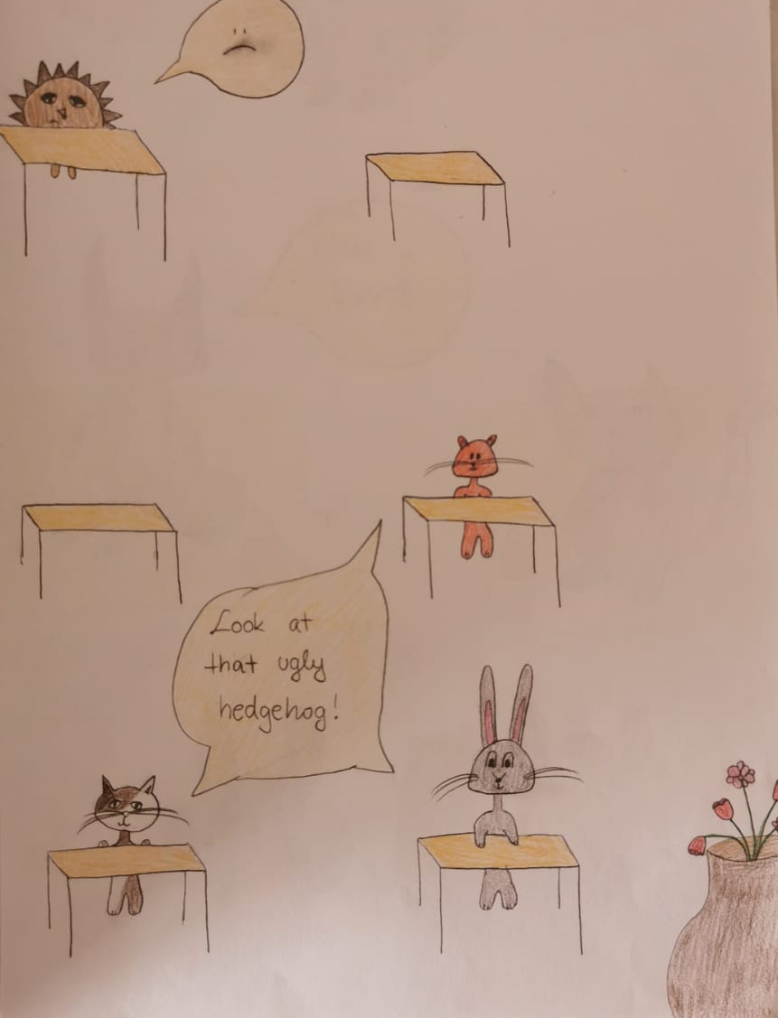

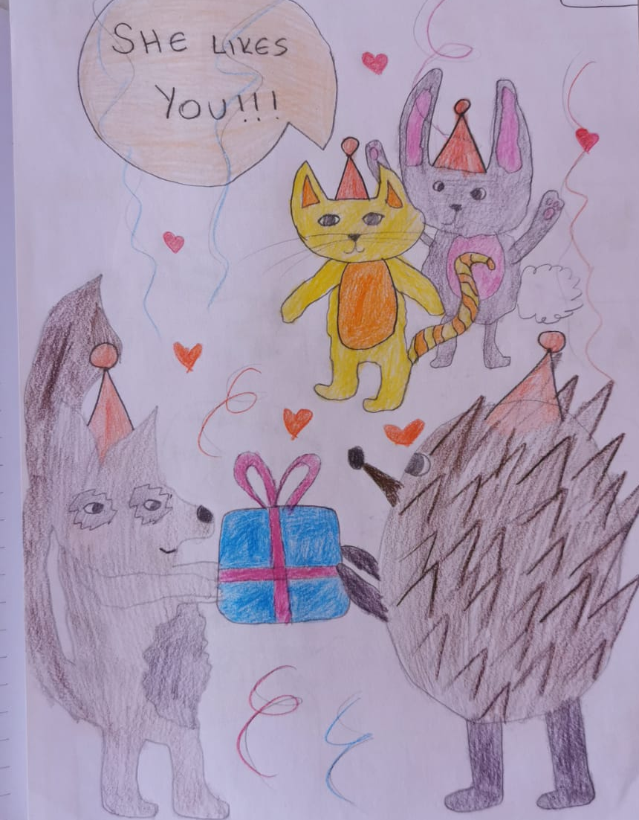
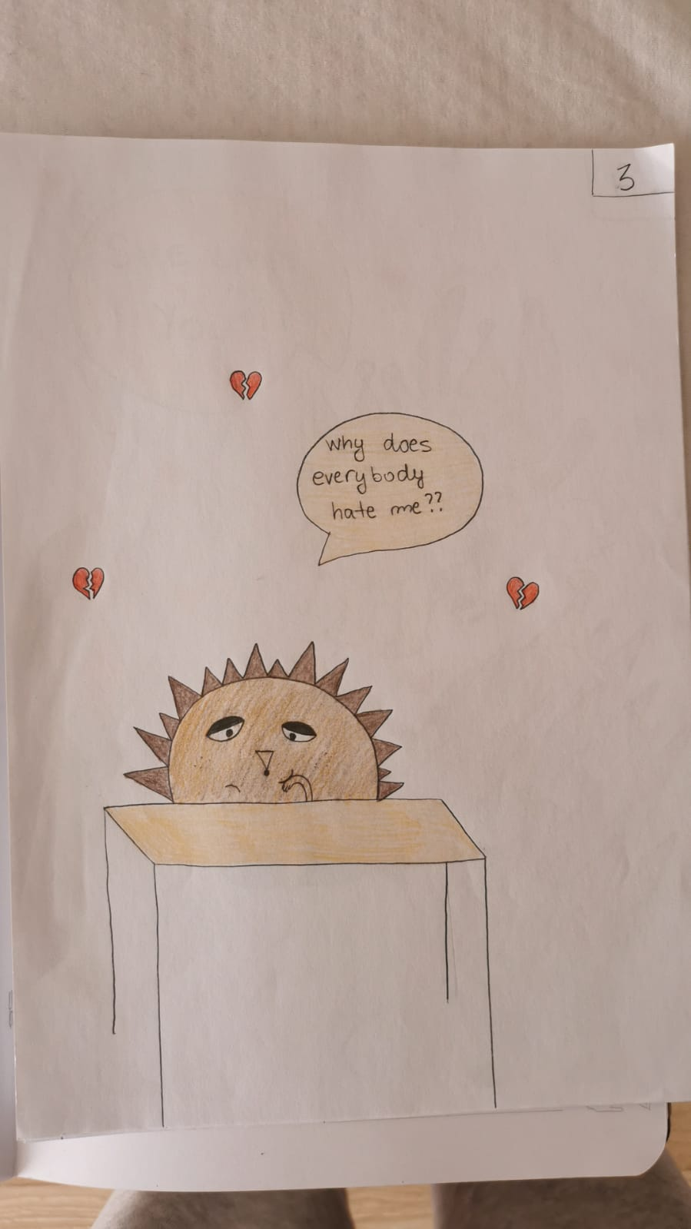

John’s love for Anne

The Valentine's Day was just around the corner and I planned to spend it alone. After all it was just another day in a week. Nothing special. My mother kept asking me about my non-existent girlfriend and secret crushes I didn’t find the time for. That was until I saw her. Anne. She was an exchange student from south of Chicago, USA. She was completely and utterly beautiful. Her golden locks that covered her shoulders were the complete opposite to her dark angora sweater that she was wearing. Her eyes were the colour of the sky on a warm summer day that often kept me locked inside my room. She smiled at me sweetly. Was she just friendly at that moment? Does she like me? Is she just trying to be nice? I wasn’t sure about lots of things, except that I needed to shoot my shot, whether she liked me or not. The important thing is that I tried.

It doesn’t matter...  If it’s right or wrong  If it’s healthy or not.  I love you and now...  I’ll admit it to you.  My heart beats, my heart throbs  It draws me straight to you ...  To tell you  Happy Valentine's day! | Nije važno...  Je li pravo ili krivo,  Je li zdravo ili ne .  Ja te volim i sad...  priznat ću ti to.  Srce mi lupa, srce mi tuče  Ono me pravo tebi vuče...  Da ti kažem  Sretno Valentinovo!

Love in many ways

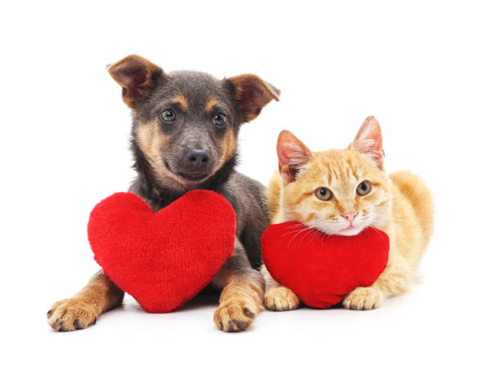

video
